INTERN OPPORTUNITY

Fauna Restoration Coordinator: Hamilton, New Zealand
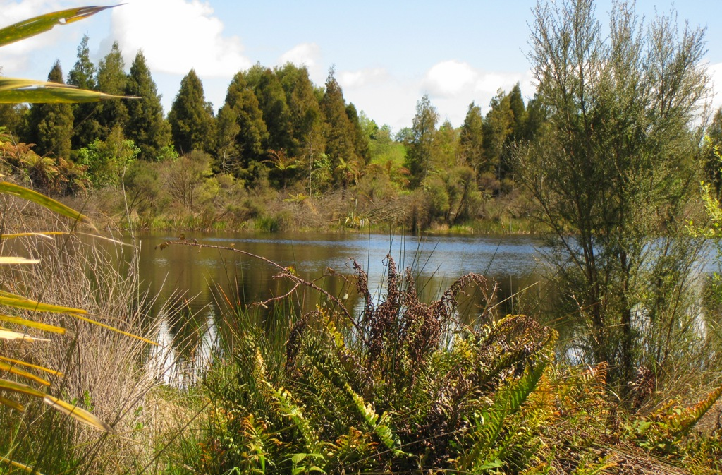
General description

The National Wetland Trust is a not-for-profit community organisation seeking to increase awareness and appreciation for wetlands. We are leading a major ecological restoration project near Hamilton, 2 hours’ drive south of Auckland. In addition to pest eradication and re-vegetation, the Trust has established a network of walkways, interpretation panels and a hands-on wetland discovery trail. We plan to return native wildlife to the site.

We have hosted several interns and can offer an office and support at one of New Zealand's leading Crown Research Agencies. Interns will meet and work with top wetland scientists as well as our committed volunteers and supporters from a range of environmental management agencies.

Your tenure will include regular visits to our restoration site - a peat lake and swamp forest sanctuary just 15 minutes’ drive from your office base. You may work with a fellow intern working on complementary projects related to the development of the National Wetland Centre. You may also work with community volunteers and wetland professionals.
Interns undertaking this role will need their own vehicle and to provide their own accommodation and food.

Primary objective The Fauna Restoration Coordinator is responsible for furthering our plans to return native wildlife to our pest-free sanctuary.
Responsible to Karen Denyer, Executive Officer, National Wetland Trust, &
Dr Beverley Clarkson, Landcare Research

Key tasks
- Develop fauna translocation plans
- Work with relevant experts to complete and implement fauna translocation plans (species may include lizards, pateke/brown teal, takahe, banded rail, NZ falcon or North Island brown kiwi)
- Assess additional fauna needs at Rotopiko, e.g. food sources, fence modifications to prevent unwanted dispersal, habitat medication e.g. cover from aerial predators
- Compile detailed budgets for translocation and monitoring.
- Work with volunteers (e.g. Menzshed) to construct soft-release/ holding pens/ falcon hack boxes or weta hotels as needed based on translocations decided upon

- Assist with fauna monitoring
- Support with bird, bat, and lizard surveys
- Conduct regular tracking tunnel checks for pest surveillance
- Analyse recordings from automatic bat and bird detectors

- Assist with marketing and fundraising for fauna restoration
- Support with Facebook campaigns and media releases
- Draft up Pledge-me/Give-a-little campaigns
- Support the EO with raising profile of the wetland centre

Possible additional tasks
- Assist our Environmental Education intern with developing an outdoor education programme at Rotopiko, e.g. act as a sounding board, test their ideas
- Conduct pest fence checks as needed (to fill vacant spots)
- Attend volunteer working bees including Weed Free Friday
- Assist a local community group with pest control via trapping in the catchment
- Assisting Landcare Research scientists

Qualifications and Skills Required
- Can communicate effectively in English.
- Experience with ecological restoration and wildlife management
- Clean NZ or International Drivers licence

Personal specifications

- An understanding of and commitment to the philosophy of volunteering
- Health and safety conscious
- Confident working outdoors
- Positive and enthusiastic and self-motivated
- Comfortable working with community volunteers

Nature of position Voluntary

Hours worked Flexible. Normal hours of work will be 37 hours per week, which may include attendance at Trust meetings or events that may be during evenings or weekends.

Reimbursement Mileage (pre-approved) reimbursement at 72 cents per km. Own car required.

Commitment A commitment of at least three months is the ideal. If circumstances change, it is preferred that at least two weeks’ notice be given.

Location Based at Landcare Research, Hamilton East, New Zealand

Agreement

National Wetland Trust will:

- Provide a suitable office space, computer and basic office supplies
- Conduct an orientation and on-the- job training and supervision.
- Ensure interns have a clear job description outlining duties which are empowering, worthwhile, interesting and challenging, yet achievable, for the intern.
- Recognise interns as professional co-workers and valued members of staff.
- Where appropriate will involve the intern in the decision-making processes.
- Provide reimbursement of intern’s authorised out-of-pocket expenses.
- Ensure interns have access to office support, and workplace guidance.
- Evaluate intern’s performance and make references available completion of service.
- Support interns in the pursuit of their personal goals and professional interests related to NWT work.
- Take all reasonable steps to provide a healthy and safe work environment and respect any requests from the intern to decline a task

The Volunteer will:

- Attend orientation, initial training and on-going training/ performance evaluation as applicable.
- Make a commitment to regular work for the National Wetland Trust and adhere to the job description unless otherwise agreed with the Trust.
- Participate in Trust meetings when required.
- Value and support fellow team members.
- Accept the guidance and supervision of the Executive Officer and Trustees.
- Engage in work ethics that demonstrate a high standard of professionalism and are aligned with the policies and philosophy of the Trust.
- Treat as confidential any information received concerning either the National Wetland Trust, Landcare Research or their partners.
- Inform the Executive Officer if for any reason he/she is unable to meet a commitment.
- Give reasonable notice of leave or resignation prior to the agreed completion date.
- Take all reasonable steps to ensure their own safety and ensure no harm is caused to others during the course of their work.

