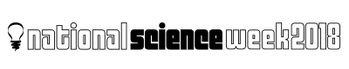
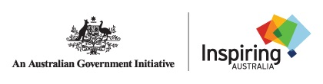

Podcasting for Science Workshop

Thursday 21 June 2018, 3pm to 6pm

Application Form

The Podcasting for Science Workshop 2018 is sponsored by the Australian Science Communicators (ASC) WA-Branch, National Science Week and Inspiring Australia.

Thanks to the support of these organisations, there is no monetary fee for attending the workshop. However in the workshop you will be guided through the production of a short podcast of a science of your choice. We ask that you be willing to share your podcast online via the National Science Week and ASC Website and related Social Media platforms.

Please email your application to asc.events.wa@gmail.com by Sunday 10 June 2018. Spaces in the workshop are limited. Successful applicants will be advised via email by Thursday 14th June.

Name
Email
Mobile
Job Title & Organisation
e.g. PhD student at ECU, freelance science communicator, etc.
Are you available on Thursday 21 June from 3pm to 6pm to attend the full workshop?
Podcast Description
Please provide a brief 100-200 word description of what you would like to podcast about.
Will you be willing to share your podcast under a Creative Commons licence so it can be used freely for advertising National Science Week?
Are you participating in National Science Week? If yes, which event?

